*GEARCRAFTWORKS ECOMMERCE WEBSITE*

Project Documentation Submitted to the Faculty of the

School of Computing and Information Technologies

Asia Pacific College

In Partial Fulfillment of the Requirements for

Introduction to Systems and Design for CS/IT

M/S NTSDEV

By

|  |  |
| --- | --- |
| Euri Marxell Lascano | Jan Christopher Reyes Francisco |
| Jouie Embudo Jr. | Kirk Clarenz Gozon |

John Marvin Sumalinog

2024

Table of Contents

I. Executive Summary 2

II. Introduction 4

1.1 Project Context 5

1.2 Statement of the Problem 5

1.4 Significance of the Project 7

I. Review of Related Literature / Systems 8

II. Current Systems 11

3.1 Current System 12

3.2 Technical Background 12

3.3 List of Processes 12

3.4 Gap Analysis 13

III. Proposed Solution 15

4.2 Lean Canvas 16

4.3 Product Vision 17

4.4 Technology Specifications 18

4.5 Feasibility 19

V. Requirements Analysis 20

5.1 Product Backlog / User Stories 20

5.2 Use Case Diagram 21

5.3 User Classes and Characteristics 24

5.4 Prototype 25

5.7 Release Plan 26

References 27

Appendices 28

Appendix A: Project Vision 29

Appendix B: Schedule/Release Plan 29

Appendix C: Product Roadmap 30

Appendix E: Teams Meetings 31

# Executive Summary

Project: GearcraftWorks E-commerce Platform

Objective: To create a comprehensive online platform for Works Team Wear, enabling streamlined business operations and enhanced customer experience through features like a custom sportswear designer, integrated inventory management, and efficient ordering processes.

Scope: The project will involve the development of a responsive e-commerce website using HTML, JavaScript, PHP, and Visual Studio Code. It will focus on providing a user-friendly interface, robust backend functionality, and a seamless customer journey.

Target Audience: Business owners in the custom sportswear industry and their customers seeking a personalized and efficient platform for designing and purchasing tailored products.

Methodology: An agile development approach will be employed, prioritizing iterative development, continuous testing, and stakeholder feedback. This ensures the project aligns with evolving requirements and delivers a high-quality product.

Expected Outcomes:

* A fully functional e-commerce platform with a user-friendly interface.
* A customizable sportswear designer tool for customers to create unique designs.
* An integrated inventory and ordering system for efficient management and fulfillment.

Benefits:

Improved business efficiency and reduced operational costs for Works Team Wear.

Enhanced customer experience through a personalized and convenient platform.

Valuable learning opportunities for the development team, including practical experience in web development, project management, and user-centered design.

Next Steps: Finalize the development of the 2D designer, integrate the inventory and ordering systems, conduct thorough testing, and prepare for the official launch.

Key Stakeholders: Project team, Works Team Wear, and end-users (customers).

By successfully implementing this project, GearcraftWorks will establish itself as a leading provider of custom sportswear, offering a superior online experience for both businesses and consumers.

# Introduction

E-commerce website users are now increasing, having a feature that can help the user and the business is the key to having a successful E-commerce website. Also, well well-managed website is the top priority in terms of regular maintenance, and updates, to ensure the security of the website. According to Kennedy (n.d), website security is a primary concern for all website owners. Cyberattacks, data breaches, and malware pose real threats that can compromise websites.

## Project Context

Works Team Wear sells customized sportswear and currently uses Facebook for their business. They have an old website, but it was left behind because it is not an e-commerce site; it only displays their products without a selling feature. The client wants the developers to build an e-commerce website with a selling feature, 2D design, inventory system, and ordering system. Facebook does not have these features to meet the client's and customers' needs, which affects their business. Customers are having a tough time explaining the designs they want. The client relies exclusively on paper to record customer orders and inventory details and does not use any digital systems for tracking this information.

## Statement of the Problem

General Problem:

The Works Team Wear old website has no e-commerce website with a selling feature and a system that can record their orders and inventory.

1. The design of the customer does not match the output design of the client due to lack of explanation and example.

2. Our client frequently misplacing the ordering form due to unorganized list of orders

3. The client miscounts the inventory weekly and sometimes it get lost due to records being only on paper

* 1. General Objective:

Works Team Wear wants the developers to create an e-commerce website that can sell products and a 2D- designer that is free and can help the customer build their design fast, also they want the developers to build an ordering and inventory system Because they only use ordering form for the details of the order and they manually inputting the inventory through paper.

Specific Objective

Eliminate Inventory Mistakes - The solution that the developers have for this is to build an inventory system. It will automatically tally the inventory. The input of the user after the shipment is only needed.

Ordering system for the client - The system will generate a list of orders from the customers, and it will eliminate the issue about misplacing the order.

2D-Designer for the customer - Customers can now create their designs with ease because of this feature and explain the design they want precisely. On the other platform, before you can fully use the 2D designer you need to buy a membership. In our 2D-designer it does not require the customer to buy a membership.

## Significance of the Project

This will be a huge benefit for our client and for other business owners that are facing the same problem. The result in this study can help those business owners that are thinking about building a website or not. If the project is effective, the clients' work will be much easier, having a website with a selling feature and designer can help the business well. Having a reliable website can attract customers

With the statements above, the following will benefit the proposed project:

* Business owner's – By creating a project that like this, it can inspire them to build a website that can help their business.
* Customer – They can now shop easily with a better experience and create their own design
* Future Developers - Studies like this will be a helpful reference resource for others if they are conducting on the same problem.
  1. **Scope and Limitations**

The developers will create an E-commerce website with a 2D design, Inventory and ordering system. This will help the client to make his work easier and for the consumer it allows them to make their own design by using the 2D designer. Adding a chatbot can help the client in some specific tasks, and it allows the customer to ask questions without contacting the client.

Limitation:

The questions that you can ask in the chatbot are limited. It can only answer within business matters only.

While developing the new e-commerce website for Works Team Wear, integrating with existing systems, such as the Excel-based inventory, may be challenging. Some users might find the 2D designer hard to use, and the options for customizing designs will be limited to what is pre-set in the tool. Additionally, the chatbot may only handle basic questions, and the availability of online moderators to help customers might vary.

# Review of Related Literature / Systems

This includes comparison of their functionalities, target audiences and their respective unique value proposition.

1. **Owayo**

Functionalities: Owayo.com specializes in customizable sports apparel, offering a wide range of products such as jerseys, shorts, and accessories tailored to individual team needs, featuring high-quality materials and customization options.

Target Audience: Owayo.com targets sports teams, clubs, and organizations worldwide looking for personalized and durable sports uniforms that reflect team identity and enhance performance.

Unique Value Proposition (UVP): Owayo.com sets itself apart with its online customization tool that allows customers to design their own sports apparel from scratch, coupled with a commitment to premium materials, quick production turnaround, and global shipping, ensuring satisfaction for teams seeking both functionality and individuality in their uniforms.

2. Spize

Functionalities: Spized.com specializes in customizable sports apparel, offering a variety of products such as jerseys, uniforms, and accessories tailored to the specific needs of sports teams and individuals. They emphasize high-quality materials and a user-friendly customization interface to create personalized sports gear.

Target Audience: Spized.com targets sports teams, clubs, and individual athletes seeking customized and durable sports uniforms that reflect team identity or personal style. Their offerings cater to a global audience looking for bespoke sports apparel solutions.

Unique Value Proposition (UVP): Spized.com stands out with its online customization platform that allows customers to design and personalize sports apparel to their exact specifications. They prioritize quick production turnaround, premium materials, and worldwide shipping, ensuring athletes and teams receive high-quality gear that enhances performance and showcases team unity or individual style.

3. Jersix

Functionalities: Jersix.com specializes in customizable sports apparel, offering a variety of products such as jerseys and uniforms that can be personalized to fit the specific requirements of sports teams and individuals. They feature high-quality materials and straightforward customization options.

Target Audience: Jersix.com caters to sports teams, clubs, and individual athletes worldwide seeking personalized and durable sports uniforms that express team identity or personal preferences. They provide tailored solutions for athletes across all skill levels.

Unique Value Proposition (UVP): Jersix.com sets itself apart with its intuitive online customization tool, allowing users to effortlessly design and personalize sports apparel. They prioritize fast production, premium materials, and global shipping to ensure athletes receive superior gear that enhances performance while highlighting team unity or individual style.

4. Zalando

Functionalities: Zalando is a leading online fashion retailer in Europe, offering a broad selection of clothing, footwear, accessories, and beauty products. The platform provides detailed product descriptions, high-resolution images, and a virtual fitting room to enhance the online shopping experience. Additionally, Zalando offers free delivery and returns, making the shopping process convenient and risk-free for customers [1].

Target Audience: Zalando targets fashion-conscious individuals who seek the latest trends and prefer the convenience of online shopping. The platform appeals to a diverse demographic, including men, women, and children, and offers products across various price ranges to cater to different income levels [2].

UVP: Zalando's unique value proposition lies in its extensive range of fashion items, customer-friendly policies such as free delivery and returns, and innovative features like the virtual fitting room. The company's commitment to sustainability, with initiatives like the "Zalando Pre-owned" program, also resonates with environmentally conscious consumers, enhancing customer loyalty and brand reputation.

5. **Uniqlo**

Functionalities: Uniqlo focuses on creating simple and functional clothing using quality materials such as Supima cotton and innovative fabrics like Heattech, which provide warmth and comfort.

Target Audience: Uniqlo primarily targets urban consumers who appreciate minimalist aesthetics and seek versatile wardrobe staples suitable for everyday wear.

Unique Value Proposition (UVP): Uniqlo distinguishes itself by offering affordable yet stylish basics that blend comfort, durability, and global fashion trends, appealing to a diverse demographic interested in both fashion and functionality.

6. **H&M**

Functionalities: H&M offers a wide range of trendy and affordable clothing options that cater to various styles and preferences, from casual basics to fashion-forward pieces.

Target Audience: H&M targets fashion-conscious consumers, particularly younger demographics, who seek trendy and affordable clothing that allows them to express their individual style.

Unique Value Proposition (UVP): H&M stands out by continuously refreshing its collections with new designs and collaborations, providing accessible fashion that reflects current trends and seasonal styles, making it a go-to destination for affordable and stylish apparel.

7. **Shein**

Functionalities: Shein provides a vast array of trendy and budget-friendly fashion items, from clothing and accessories to shoes and beauty products, catering to a wide range of styles and preferences.

Target Audience: Shein targets fashion-forward young adults and teens who are looking for affordable and rapidly changing fashion trends, allowing them to experiment with their style without breaking the bank.

Unique Value Proposition (UVP): Shein's unique value lies in its extensive and constantly updated inventory, offering on-trend fashion pieces at very competitive prices, combined with a user-friendly online shopping experience that emphasizes customer engagement and community feedback.

8. N**ike**

Functionalities: Nike specializes in athletic apparel, footwear, and accessories designed for performance and comfort, featuring innovative technologies like Nike Air and Dri-FIT fabric for moisture management.

Target Audience: Nike primarily targets athletes and sports enthusiasts of all ages and levels, offering products that enhance performance while also appealing to casual wearers who value style and comfort.

Unique Value Proposition (UVP): Nike's unique value proposition lies in its commitment to innovation and performance-driven design, combined with a strong brand identity that promotes athleticism, inspiration, and empowerment, making it a leading global brand in sports apparel and footwear.

9. **Shopee**

Functionalities: Shopee describes itself as an innovative mobile platform with an easy-to-use interface and integration of gaming elements into shopping. It includes social networking elements with the ability to share suggestions between users. Shopee also focuses on budget customers with regular discounts and coupons [3].

Target Audience: Shopee’s business model is aimed at cost-sensitive customers and those with experience in mobile shopping. The gamification trend and the use of social media channels target younger audiences [4].

UVP: Shopee’s UVP revolves around its mobile-first platform, social commerce functionalities, and cheaper prices. All these elements appeal to the increasingly mobile-savvy population in Southeast Asia.

10. **Lazada**

Functionalities: Lazada provides a plethora of products used in the Southeast Asian region. It collaborates with known names and offers several modes of payment, such as cash on delivery. Lazada also focuses on creating more customer experience through chat support and return policy [5].

Target Audience: Lazada aims to reach a general market of Southeast Asia clients by providing a diverse range of products and flexible payment options. Concentration on service fulfillment can serve those who are looking for a safe and easy buying experience [6].

UVP: Lazada’s unique value proposition includes its focus on Southeast Asia and addressing regional needs, with flexible payment methods. This focus on customer service creates trust and helps customers to remain loyal.

The strategic positioning of Amazon, Shopee, and Lazada is different from one another in terms of the targeted market segment and the value offered. Amazon has the widest range of products and offers the best delivery solutions, Shopee is all about providing the best device-based low prices, and Lazada is dedicated to the customers and culture of Southeast Asian countries. According to these needs and preferences, the desired platform for a user may vary.

# Current Systems

## 3.1 Current System

Gear Craftworks is currently using desktop computers, laptops, printers for clothing or Digital shirt printers, and Microsoft Excel. They contacted their customers using Facebook Messenger so they can respond and take their Sportswear design orders. They are also currently using PLDT Fibr Internet Provider as their main network.

## 3.2 Technical Background

Software: The design team uses 2D Rendering Software to create and visualize jersey and pants designs.

Hardware: Computers are used for designing and managing operations.

Network: Internet connectivity is a must for accessing designing software, managing online sales, and communicating with customers and suppliers

## 3.3 List of Processes

|  |  |  |
| --- | --- | --- |
| Process ID | Process Name | Process Details |
| P001 | Facebook:   * Posting Sportswear Designs | 1. The company will post their sportswear designs for their advertisements |
| P002 | Facebook Messenger or Email   * Uploads/Create a design using the 2D Design Tool * Ordering in Works Team Wear | 1. Customers will ask if the items are available, and they will ask for the price  2. The Company will ask their Name, phone number, and address, so they can proceed with the delivery. |
| P003 | Digital Shirt Printer:   * Printing the SportsWear | 1. The Company uses their machine to print the customer’s sportswear design |
| P004 | Ordering Form   * View and Manage Orders * Listing Customers details of their order. | 1. The client will get the ordering from the client |
| P005 | Manual Inventory   * Checking the Inventory | 1. The client will manually count the inventory and write it on paper. |
| P006 | Payment Method   * GCASH   Online Bank Transferring Apps | 1. Before the company delivers the product to the customer, the delivery will have to contact the cashier if the payment has been successfully transferred.  2. If confirmed, the courier is ready to deliver the customer’s product. |

## 3.4 Gap Analysis

Table 2 Gap Analysis

|  |  |  |
| --- | --- | --- |
| Current State | Desired State | Impact |
| P001 | The contact information of each customer will be stored in the database so that if the customer orders again, it has an automatic contact information | High |
| P002 | Manually checking/counting inventory every end of the day/shift | High |
| P003 | Manually checking on the receipts that has been made if it’s still pending or not yet prepared | High |
| P004 | Manually printing sales report by clicking each transaction of the day | Medium |
| P005 | Manually Printing the Sportswear | High |

**SWOT Analysis**

|  |  |
| --- | --- |
| **Strength** | **Weaknesses** |
| * Large User Base: Facebook has a massive and diverse global user base, providing access to a wide audience. * Targeted Advertising: Advanced advertising tools allow precise targeting based on demographics, interests, and behavior. * Engagement Tools: Interactive features such as comments, likes, and shares increase engagement and brand visibility. * Cost-Effective: Setting up a business page is free, and advertising can be cost-effective compared to traditional media. * Integration: Easy integration with other e-commerce tools and platforms, including Facebook Shops and Instagram Shopping. * Trust and Credibility: Established platform with high user trust, which can translate to credibility for your business. | * Dependency on Platform: Heavy reliance on Facebook's algorithms and policies, which can change unpredictably. * Limited Customization: Less flexibility in website design and user experience compared to a dedicated e-commerce website. * Data Privacy Concerns: Increasing user concerns about data privacy on Facebook may affect customer trust. * Competition: High competition from numerous businesses using the platform for similar purposes. * Algorithm Changes: Organic reach can be significantly affected by changes in Facebook's algorithm, requiring increased ad spend. |
| **Opportunities** | **Threats** |
| * Expanding Features: Continuous development of new tools and features by Facebook to support e-commerce. * Social Commerce Growth: Increasing trend of social commerce, with more people willing to shop directly through social media. * Collaborations: Potential for partnerships with influencers and other businesses on Facebook to enhance reach and credibility. * Mobile Commerce: Growing use of mobile devices for shopping, and Facebook's mobile-friendly platform supports this trend. * Customer Insights: Access to detailed analytics and customer insights to refine marketing strategies and product offerings. | * Platform Risks: Risk of account suspension or restrictions due to policy violations or algorithm changes. * Cybersecurity: Potential for hacking and data breaches, which could compromise customer information. * Market Saturation: High saturation of businesses on Facebook, making it difficult to stand out without significant investment in marketing. * Changing Consumer Behavior: Shifts in consumer preferences and behavior that might move away from social media shopping. * Regulatory Changes: Potential impact of changes in data privacy laws and regulations on how businesses can use Facebook for e-commerce. |

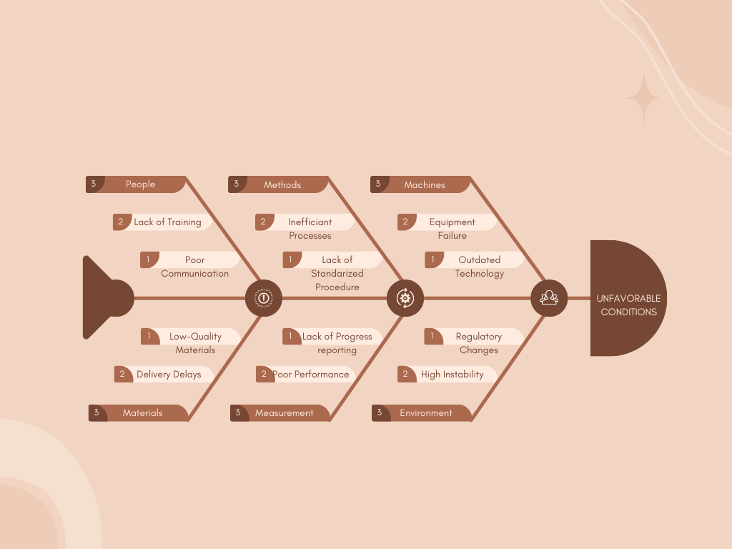**Fishbone Diagram**

**Figure 1: Fishbone Diagram**

# Proposed Solution

## 4.2 Lean Canvas

***Problem*** *-*

1. The design of the customer doesn't match the output design of the client due to lack of explanation and example.

2. The client frequently misplaces the order forms due to an unorganized list of orders.

3. The client miscounts the inventory weekly and sometimes it gets lost due to records being only on paper

***Solution*** *-*

1. 2D designer - To help our customers to explain well the design they want, to achieve getting the right output of design from the client.

2. Ordering System - To help our client to eliminate the issue of misplacing the list of orders and unorganized orders.

3. Eliminate Inventory Mistakes - To eliminate the inventory mistakes and to prevent getting lost of the records.

***Unique Value Proposition*** *-*

Our e-commerce platform offers tailored 2D design customization for sportswear, allowing customers to personalize their athletic apparel with unique graphics for a seamless shopping experience with no subscription needed.

***Customer Segment*** *-*

* Sports enthusiasts looking for personalized gear.
* Teams and clubs seeking uniform customization.
* Suppliers.  
  ***Channels*** *-*
* Advertising on Facebook through showcasing, videos and calling card.

***Revenue Streams*** *-*

* + Sales of customized sportswear

***Cost Structure*** *-*

* + Website development and maintenance.
  + Domain Name and Hosting
  + SSL Certificate and Payment Processing Fees.

***Unfair Advantage*** *-*

* + Providing a unique customer experience that will allow them to create their dream sportswear.
  + The system will allow them to customize their printed design, chosen fabric, and sewing techniques.

## 4.3 Product Vision

The GearcraftWorks website and 2D design tool aim to revolutionize the sports apparel industry by providing teams worldwide with an intuitive, high-quality platform for creating personalized sportswear. Our cutting-edge online solution and unique shirt/jersey designer tool will empower teams to effortlessly design and customize their apparel to reflect their unique style and spirit. By seamlessly integrating technology with craftsmanship, we strive to become the go-to online destination for superior sportswear that combines functionality and team unity.

Through our platform, teams can fully customize every aspect of their sportswear, from design to raw materials, ensuring their needs and preferences are met with precision and excellence. Our goal is to set new standards in differentiation, innovation, and utility, delivering revolutionary changes and a lasting impact on the sports apparel market for athletes, coaches, and enthusiasts alike.

|  |  |
| --- | --- |
| **For** | Business Owners |
| **Who** | Needs an e-commerce website with a designer feature. |
| **The** | Gear Craftwork is an e-commerce website that has a designer feature that can help the consumers to edit their own shirt/jersey |
| **That** | It will help the business owner on knowing what design the consumer wants and it will reduce the time taken in knowing/choosing the design |
| **Unlike** | The other sellers just use Facebook to sell their products and they don't have a designer. |
| **Our Project** | Will help everyone in the business to make their work easier. |

## 4.4 Technology Specifications

|  |  |  |
| --- | --- | --- |
| Category | Technology | Details |
| Hardware | Personal Desktop  Android Tablet | Windows OS, Android 14 |
|  | Networking Equipment | Network Provider PLDT Fibr for connectivity during development |
| Software | Operating System | Windows OS, Android 14 |
|  | Development Tools | Visual Studio Code for coding and debugging |
|  | Frontend Technologies | HTML, JavaScript for creating responsive and interactive UI |
|  | Backend Technologies | PHP for server-side scripting and dynamic content management |
| Peopleware | Development Team | Individual developer working on project setup |
| Network | WiFi Network | Connectivity and accessing internet resources |

## 4.5 Feasibility

**Operational Feasibility**

This project does not need any training for the workers of the company. The customers need a guide on how to use our 2d designer and we will put a guide below our 2d designer. The new system will result in a time reduction in terms of getting the design from the customers. Now in this proposed system the customers can now create their intended cloth design on the website, and they can send it directly to the shop. The customer experience will be enhanced because of the interactions that we have.

**Economic Feasibility**

The developers will not demand developer's fee in creating this project. The hosting of the website will cost 1 dollar. This project will have a positive outcome in terms of cost management.

**Technical Feasibility**

The web-based project can be accessed on any device. The customers can access the website through them

computer, laptop, cellphone, tablet. For the business owner they can manage the website by using a computer or laptop.

**Schedule Feasibility**

The project's schedule feasibility is based on the road map they created, so that the developers can ensure they can finish the project on time without any risk that will lead to losing it.

# Requirements Analysis

## Product Backlog / User Stories

Product Backlog Example

|  |  |  |  |  |
| --- | --- | --- | --- | --- |
| ID | As a.... | I want to be able to... | So that... | Priority |
| 1 | User | Create an account | I can use the website | Medium |
| 2 | User | Log in to my account | I can buy from the shop | High |
| 3 | User | The option to reset my password, in case I forget it. | My team can collaborate it | Medium |
| 4 | Admin | Manage user accounts and permissions. | I can control access to the system and its features | High |
| 5 | User | Choose the type of jersey (e.g., football, basketball, soccer) | I can select the appropriate design template | High |
| 6 | User | Select jersey size and color | I can customize the jersey to fit my preferences | High |
| 7 | Admin | view and manage all orders, including status | I can track and fulfill orders efficiently | High |
| 8 | Admin | Generate invoices and receipts for orders | I can maintain accurate records of transactions | High |
| 9 | User | Securely pay for order using various payment methods | I can complete my purchase with confidence | High |

# 5.1.1 Data Flow Diagram Level 0

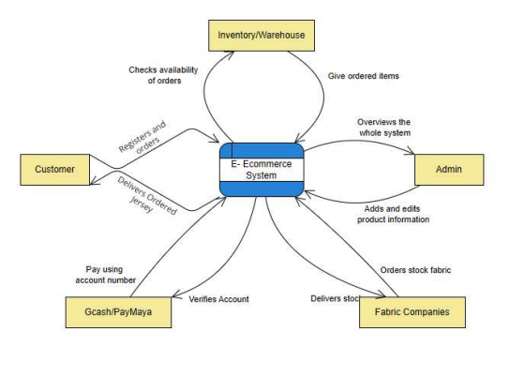

**Data Flow Diagram Level 1**

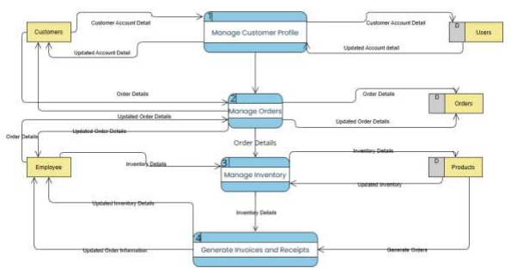

**Data Flow Diagram Process 1 – Manage Customer Profile (Level 2)**

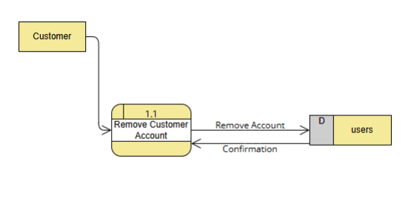

**Data Flow Diagram Process 2 (Level 2)**

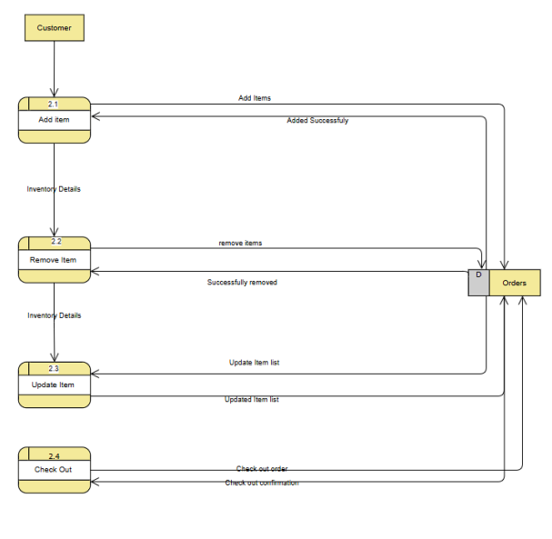

**Data Flow Diagram Process 3 (Level 2)**

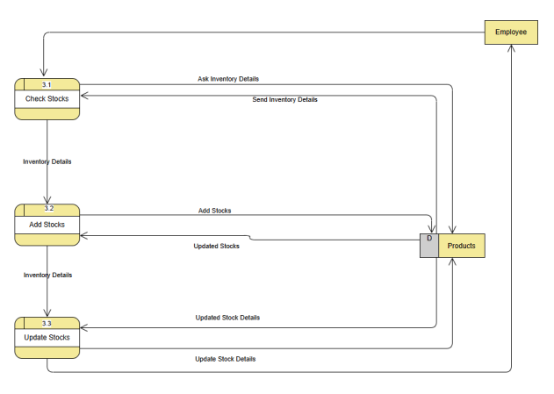

## Use Case Diagram

**Figure 2: Use Case Diagram**

## Use Case Full Description

|  |  |  |  |  |
| --- | --- | --- | --- | --- |
| Use Case Name: | Manage Customer Profile | | | |
| Date Created: | 08/28/2024 | | | |
| Description: | This case allows the user to edit or manage the name, address, contact number, or password that is registered to their account. | | | |
| Primary Actor: | Customer | | | |
| Secondary Actor: | Admin | | | |
| Include use cases: |  | | | |
| Preconditions: | * Account should be exist * Account should be logged in | | | |
| Postconditions: | • Account changes will be applied | | | |
| Main Flow: |  | Actor | System |  |
|  |  | 1. The customer will have to register their account by using “Sign-up” button. 2. The customer will   have to fill their required information inorder to complete their registration   1. Customer can edit their user details by clicking their profile 2. Customers can edit/add information for their account 3. Customer clicks on the “save” button 4. Customer closes the “Manage Account” screen | 1.1 System opens the registration page    2.1 System saves the user information that it was entered for the account to be created    3.1 System opens the  “Manage Account” page    4.1 System will change the  account details that the  customer changed    5.1 System will pop-up a message “Are you sure to  save your changes?”    6.1 System closes the  “Manage Account” page |  |

|  |  |  |  |  |  |
| --- | --- | --- | --- | --- | --- |
| Use Case Name: | Manage Orders | | | | |
| Date Created: | 08/29/2024 | | | | |
| Description: | The customer wants to create or make an order | | | | |
| Primary Actor: | Customer | | | | |
| Secondary Actor: | Employee | | | | |
| Include use cases: |  | | | | |
| Preconditions: | • Must be logged-in to a customer account or an employee account | | | | |
| Postconditions: | * Orders must be visible on the pending page of the employee dashboard * Requests must be visible in the pending return page of the employee dashboard | | | | |
| Main Flow: |  | **Customer** | **Employee** | **System**  **(Employee)** |  |
| 1. Customer  clicks “All Categories” | 1. Employee clicks on  “All  Categories” | 1.1 System displays the categories |
|  |  | 1. Customer chooses and clicks on a product 2. Customer sets a quantity 3. Customer clicks the “Add to cart” button or “Buy now” button 4. Customer goes to “My Orders” page | 1. Employee chooses and clicks a product 2. Employee sets the quantity 3. Employee clicks the “add to cart” button 4. Employee clicks the “Reports” from the dashboard page. | 2.1 System opens the product page. 3.1 System validates the quantity of order with the remaining stocks.  4.1 System adds the item to the  employees  “Cart” 5.1 System opens the dropdown |  |

|  |  |
| --- | --- |
| Use Case Name: | Manage Inventory |
| Date Created: | 8/29/2024 |
| Description: | This use case involves tracking and managing the stock levels of custom shirts. |
| Primary Actor: | Admin |

|  |  |
| --- | --- |
| Secondary Actor: | Employee |
| Include use cases: | Add New Product, Update Stock Levels. |
| Preconditions: | The inventory system must be operational, and the employee or admin must be logged in. |
| Postconditions: | Inventory levels are updated in the system. |
| Main Flow: | 1. Admin accesses the inventory management module. 2. Admin adds or updates the product details. 3. System saves the changes and updates the stock levels. 4. System provides a summary of the updated inventory. 5. Admin closes the inventory management screen. |

|  |  |
| --- | --- |
| Use Case Name: | Manage Invoice |
| Date Created: | 8/29/2024 |
| Description: | The case would involve creating, viewing, and managing invoices for customer orders. |
| Primary Actor: | Employee |
| Secondary Actor: | Admin |
| Include use cases: | Generate Invoice, View Invoice History. |
| Preconditions: | An order must be completed, and the customer account should be registered. |
| Postconditions: | An invoice will be generated and linked to the respective order. |
| Main Flow: | 1. Employee selects the completed order. 2. System generates an invoice for the order. 3. Employee reviews the invoice details. 4. Employee confirms and sends the invoice to the customer. 5. System updates the order status as invoiced. |

|  |  |
| --- | --- |
| Use Case Name: | Manage Employee Account |
| Date Created: | 8/29/2024 |
| Description: | This use case involves managing the creation, editing, and deletion of employee accounts. |
| Primary Actor: | Admin |
| Secondary Actor: | Employee |
| Include use cases: | Create Employee Account, Edit Employee Account. |
| Preconditions: | Admin must be logged in. |
| Postconditions: | Changes to employee accounts are saved in the system. |
| Main Flow: | 1. Admin selects the option to manage employee accounts. 2. Admin creates or selects an existing employee account. 3. Admin updates the details or deletes the account. 4. System saves the changes. 5. System updates the employee list. |

|  |  |
| --- | --- |
| Use Case Name: | Manage Supplier |
| Date Created: | 8/29/2024 |
| Description: | This use case involves managing the details of suppliers who provide the raw materials or products. |
| Primary Actor: | Admin |
| Secondary Actor: | Employee |
| Include use cases: | Add Supplier, Update Supplier Information. |
| Preconditions: | The admin must have access to supplier management. |
| Postconditions: | Supplier information is updated and stored in the system. |
| Main Flow: | 1. Admin accesses the supplier management module. 2. Admin adds or updates supplier details. 3. System saves the supplier information. 4. System displays the updated supplier list. |

|  |  |
| --- | --- |
| Use Case Name: | Manage Reports |
| Date Created: | 8/29/2024 |
| Description: | This use case involves generating and viewing various reports related to sales, inventory, and customer activity. |
| Primary Actor: | Admin |
| Secondary Actor: | Employee |
| Include use cases: | Generate Sales Report, Generate Inventory Report. |
| Preconditions: | The system must have data to generate reports. |
| Postconditions: | Reports are generated and stored for future reference. |
| Main Flow: | 1. Admin selects the type of report to generate. 2. System gathers the required data. 3. System generates the report. 4. Admin reviews and saves the report. 5. System logs the report generation activity. |

* + 1. **Test Cases**

**Figure 4: Activity Diagram with Swimlanes** 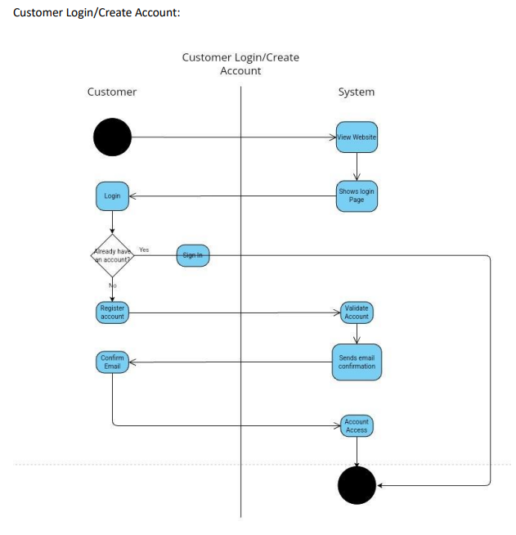

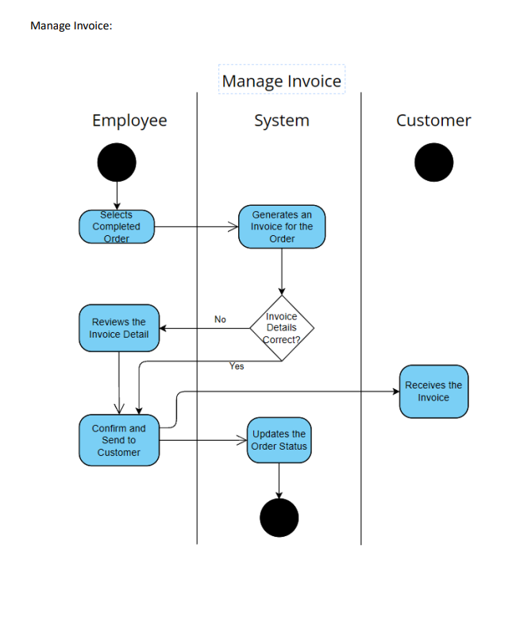

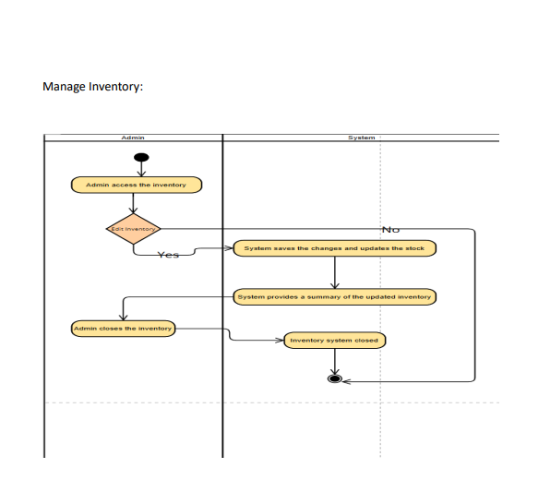

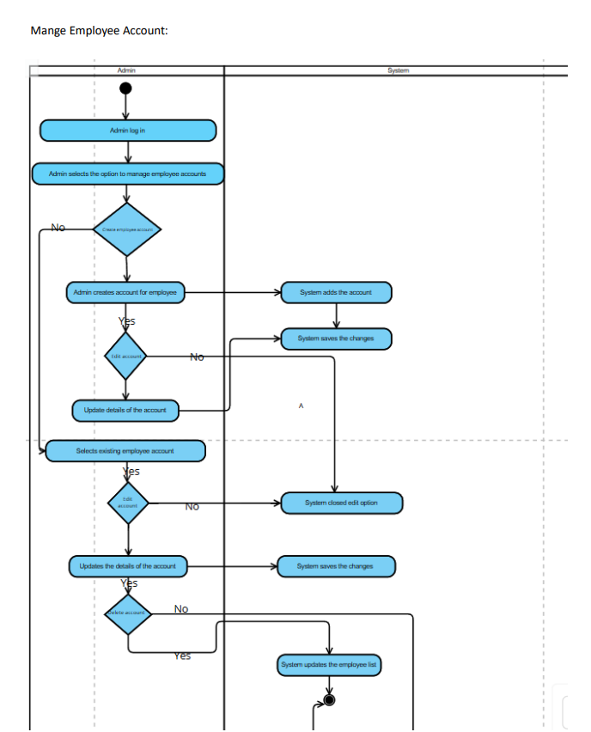

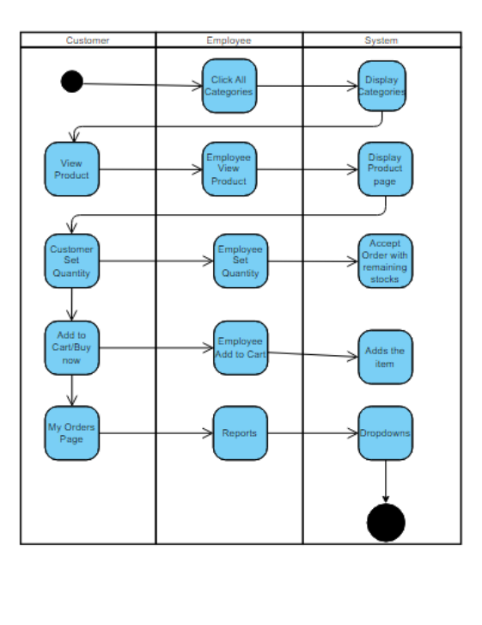

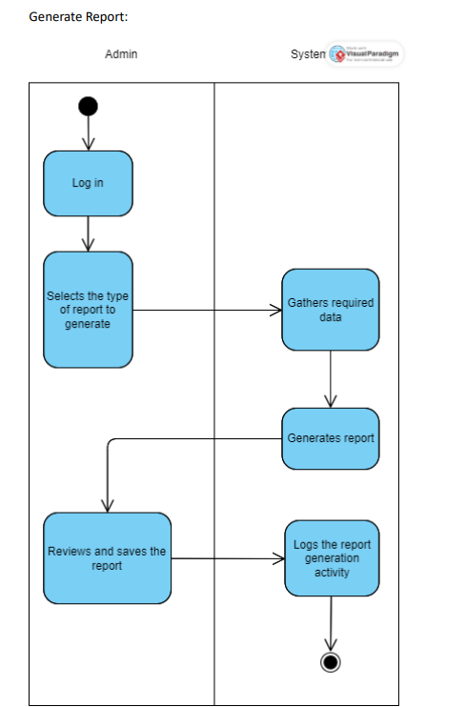

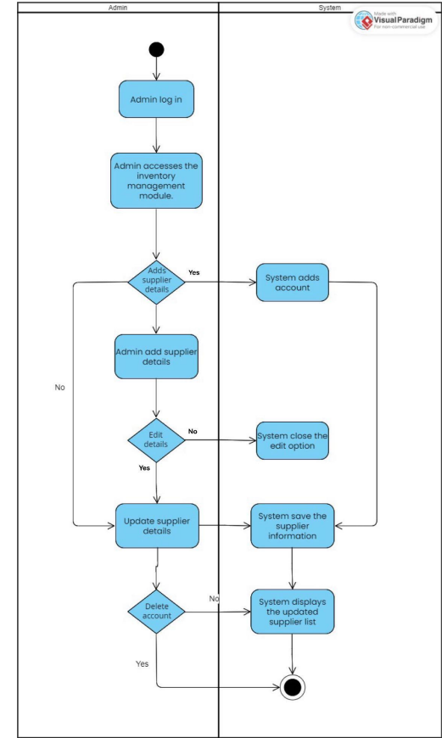

## Prototype

### 

Here is the mid-fidelity wireframe of the landing page of the website. The users can use their email or continue with google, Facebook to sign in.

Figure 3 Low-Fidelity Wireframe: Landing Page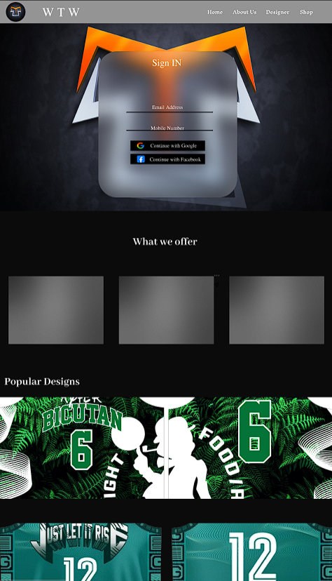

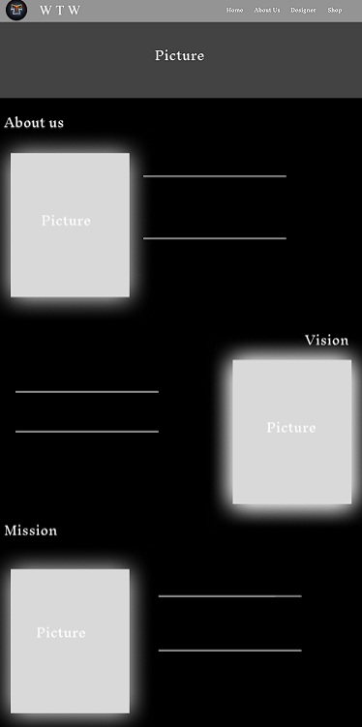

Figure 4 Low-Fidelity Wireframe: About Us

This is the mid-fidelity wireframe for the “About us” page. After they click “About us” the users will see the vision and mission of the company.

For the designer page, here is the mid-fidelity wireframe for it. They will see a shirt that they customize by their intended color, text, font, logo. Also, they can use paint brush mode for more design.

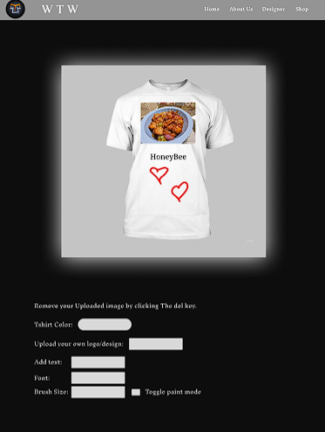

Figure 5 Low-Fidelity Wireframe: Designing Page

This figure shows the mid-fidelity of the “Shop” page. They can use the category button to select what type of sport design they want. They can freely choose the size and color of the product they want. We put a rating and comment section below the product so they can see the opinions of those who already bought the product. Lastly, the developers put a filter so that the users can easily check the feedback of the product that they want to see.

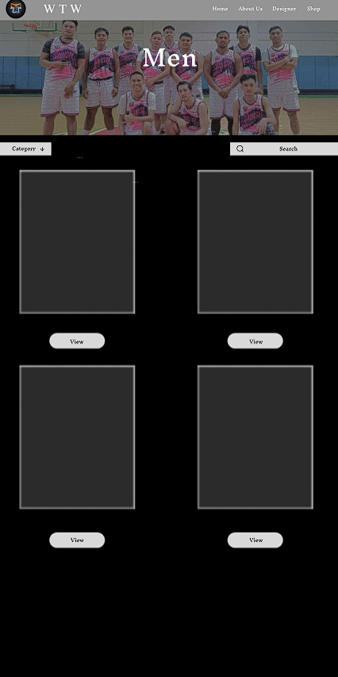

Figure 6 Low-Fidelity Wireframe: Men’s Page

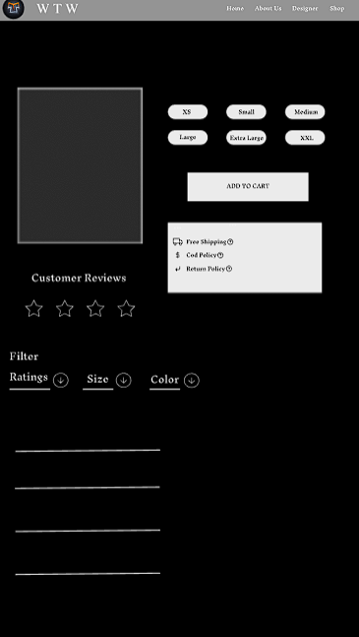

Figure 7 Low-Fidelity Wireframe: Add to Cart Page

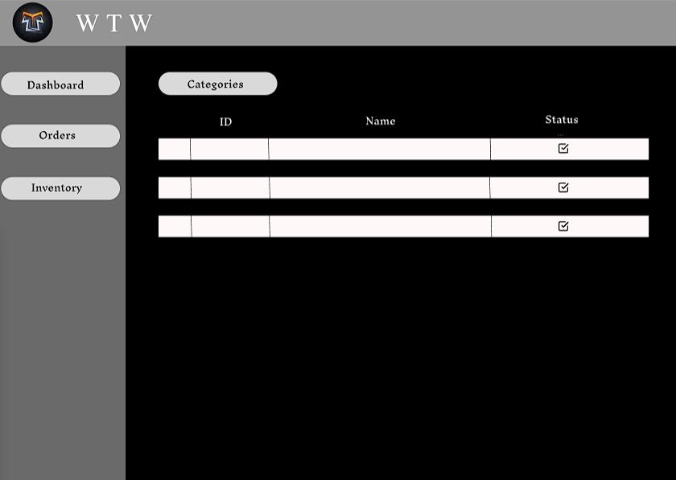The client will able to see their inventory and orders through this system

Figure 9 Low-Fidelity Wireframe: Inventory and Ordering System

## 5.7 Release Plan

|  |  |
| --- | --- |
| Release | Task |
| Release 1 | - Research Paper  - Prototype |
| Release 2 | - Fixing the 2D designer  - Creating the Chatbot  - Designing the website |
| Release 3 | - Users can access the website  - Users can log-in through email or continue with Facebook  -They can create their own design by using 2d-designer  - Users can make payment online  - Users can place an order  - Users can ask questions from the chatbot Buttons are fixed  - Search bar is working |

# References

[1] Zalando, "About Us," [Online]. Available: https://www.zalando.com/about-us/. [Accessed: 27-Jun-2024].

[2] L. Johnson, "Zalando: A Case Study in Online Fashion Retailing," Fashion Business Review, vol. 12, no. 1, pp. 23-35, 2023.

[3] J. Tan and Z. Liu, "The impact of gamification on user engagement and customer loyalty in mobile shopping platforms," International Journal of Information Management, vol. 62, 2022, Art. no. 102428.

[4] Y. Huang and H. Chen, "Examining the factors affecting consumers' continuous intention to use mobile shopping platforms: A cross-cultural comparison," Journal of Business Research, vol. 101, pp. 622-633, 2019.

[5] S. Barnes and V. Hunt, "Understanding the motivations and barriers to online shopping in Southeast Asia," Journal of International Consumer Marketing, vol. 32, no. 2, pp. 141-158, 2020.

[6] K. Tian, Y. Wang, and J. Zhang, "How do trust perception and perceived risk affect online shopping intentions? Mediating effects of perceived value," International Journal of Retail & Distribution Management, vol. 45, no. 1, pp. 71-84, 2017.

# Appendices

## Appendix A: Project Vision

The GearcraftWorks website and 2D design tool aim to revolutionize the sports apparel industry by providing teams worldwide with an intuitive, high-quality platform for creating personalized sportswear. Our cutting-edge online solution and unique shirt/jersey designer tool will empower teams to effortlessly design and customize their apparel to reflect their unique style and spirit. By seamlessly integrating technology with craftsmanship, we strive to become the go-to online destination for superior sportswear that combines functionality and team unity.

Through our platform, teams can fully customize every aspect of their sportswear, from design to raw materials, ensuring their needs and preferences are met with precision and excellence. Our goal is to set new standards in differentiation, innovation, and utility, delivering revolutionary changes and a lasting impact on the sports apparel market for athletes, coaches, and enthusiasts alike.

|  |  |
| --- | --- |
| For, | Business Owners |
| Who, | Needs an e-commerce website with a designer feature. |
| The, | Gear Craftwork is an e-commerce website that has a designer feature that can help consumers to edit their own shirt/jersey. |
| That, | It will help the business owner to know what design the consumer wants and it will reduce the time taken in knowing/choosing the design. |
| Unlike, | The other sellers just use Facebook to sell their products and they don't have a designer. |
| Our Project, | Will help everyone in the business to make their work easier. |

## Appendix B: Schedule/Release Plan

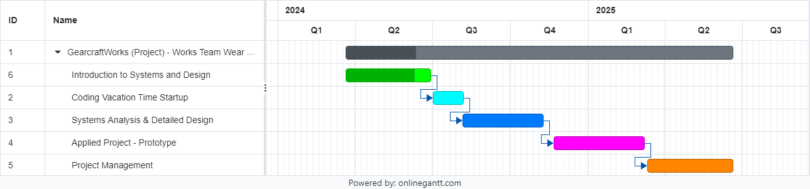

## Appendix C: Product Roadmap

|  |  |  |  |
| --- | --- | --- | --- |
| Q1 | Q2 | Q3 | Q4 |
| Milestone 1   * Looking for a client. * Brainstorming and delegating tasks on MS teams.     Milestone 2   * Initial interview with the client. * Delegating task about the Project Proposal.     Milestone 3   * Making of the Power Point Presentation * Delegating roles on reporting the Project Proposal. | **Milestone 4**   * **Presentation of our Project Proposal to our panelist.** * **Start working on our comment matrix.**     **Milestone 5**   * **Second interview with the client.** * **Consultation with the Project Adviser.** | **Milestone 6**   * **Adding details to our paper.** * **Consultation with our subject adviser about Lean Canva.**     **Milestone 7**   * **Fixing our Lean Canva.** * **Delegating task about the Project Proposal.** | **Milestone 8**   * **Polishing the SharePoint, and Power Point Presentation** * **Presentation of our Project Proposal to our Panelist** |

## Appendix E: Teams Meetings

May 23, 2024

Consultation on Final Paper

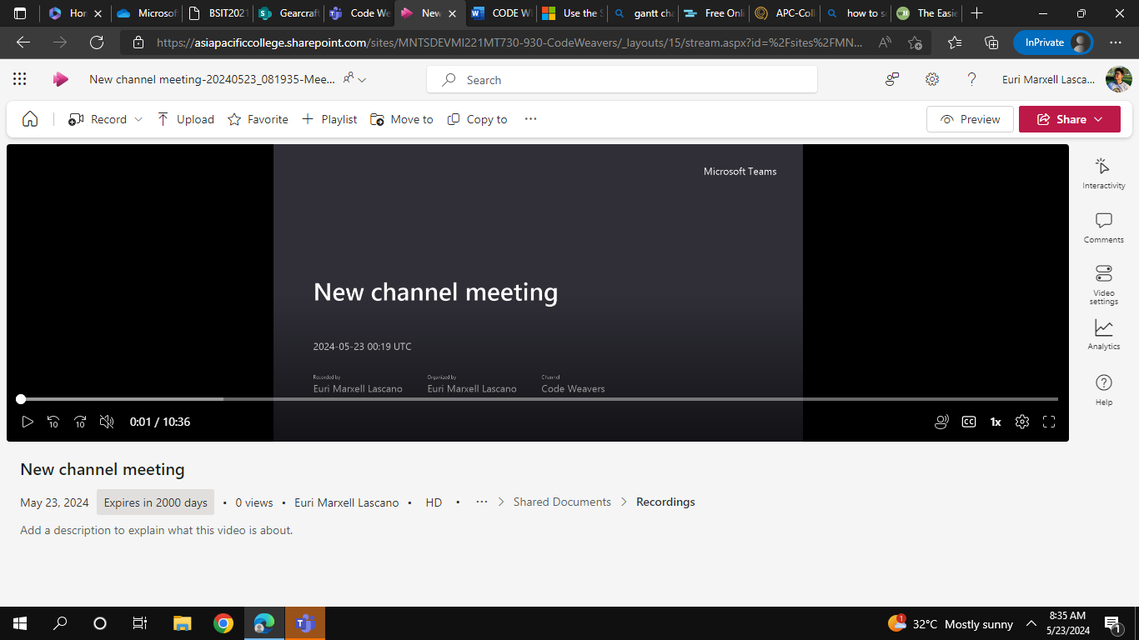

May 13, 2024

Consultation with adviser



May 23, 2024

Team meat about Lean Canva Rework

